J3ZZ LIVE SOLO – TECH RIDER

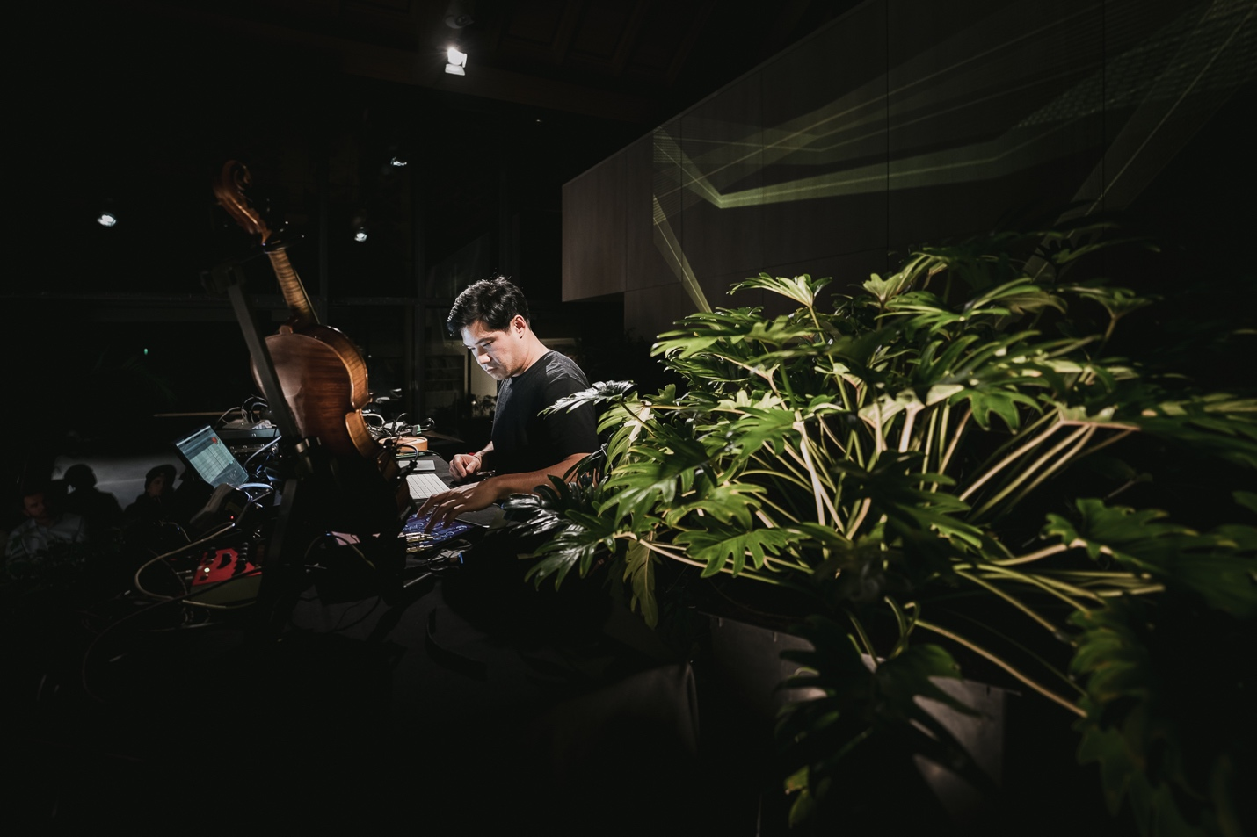
First of all, thank you for your interest in booking a show for J3ZZ Live Solo. Below is a list of our technical requirements. It might sound a bit formal to you, this is not meant to cause any inconveniences on your behalf. We designed this rider for optimum effectiveness at the day of the show. If there are any questions or if you have trouble providing any of the below mentioned please get in touch with us before the day of the show and we will work out a solution.

Contacts
Jérôme Li-Thiao-Té (J3ZZ) - Main Artist, Mic speaker. (L) - Manager +33 (0)6 98 84 55 71.
Aric Resnick (outside of Réunion island) - Sound engineer FOH. (XL)
Jérôme Ringana (on Réunion island) - Sound engineer FOH. (XL)

The venue shall supply the following:
A high-quality audio system meeting the following requirements has to be set up and be in full working order 1 hour prior to sound check. A high-quality stereo three-way active PA system with Subs capable of providing a clear non-distorted sound with an even coverage of sound throughout the venue and capable of delivering a range between 20hz-20khz. Center fills were required, depending on the width of the stage.
Sober English-speaking technicians who are experienced with the equipment and is to be available to assist for the duration of the artist’s visit to the venue.
House technicians must be available from set-up through performance.

House mix (Front Of House)

Digital Setup :
32 x 24 Digital FOH console (Midas, A&H, Yamaha, Soundcraft….) and all the technical requirements for the proper functioning, with USB capable recording.

(If) Analog Setup :
32 x 10 mixing console (Midas, Yamaha, Soundcraft…) with minimum 2 Aux Sends.
ONE (1) Equalizer Klark Teknik 1/3 octave - DN 360 (stereo)
ONE (1) Digital Reverb type Lexicon PCM 70
ONE (1) Digital Delay type Yamaha SPX 900
ONE (1) Digital multi effects
4 Channels Compressor / Gate type Drawmer, dbx
10 Channels Compressor type DBX 160A

Monitor system
Professional quality processed and bi-amplificated sound system.
*** * ALL MONITORS PROVIDED MUST BE OF THE SAME MODEL * ***
Two (2) Stage monitors handled from the FOH.
Required lighting
Stage lighting to be enough to cover the stage in a wash with colored filters and, or LED lighting colors tbd.
12 x moving head fixtures Robe, Clay Paky, Mac
Intelligent lighting console for Moving heads
Lighting operator for rehearsals and show
Fog machine

Required projection
12-20k lumen laser projectors
HDMI connection at stage laptop
Projection screen to accommodate room size

Stage plot (minimum stage dimension 6 x 4 m)

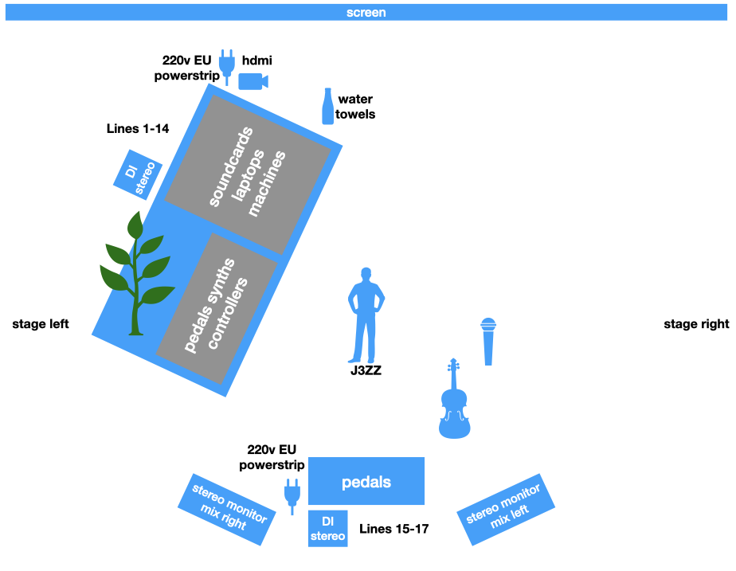
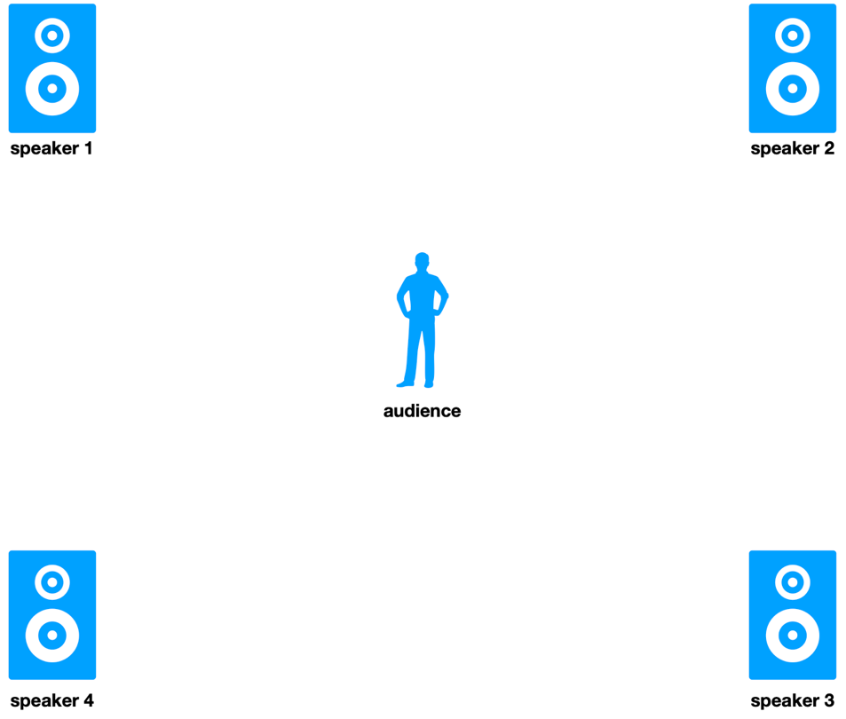

Microphones, cables, DI, mics, arm stands, stage flooring etc.

Patch List (inputs)
CH | SOURCE | MIC / DI | COMMENTS
01 | track-1 | XLR | To send to speaker-1 (Front-Left)
02 | track-2 | XLR | To send to speaker-2 (Front-Right)
03 | track-3 | XLR | To send to speaker-3 (Back-Right)
04 | track-4 | XLR | To send to speaker-4 (Back-Left)
05 | Drums-L | XLR
06 | Drums-R | XLR
07 | playback-L | XLR
08 | playback-R | XLR
09 | Vocals-L | XLR
10 | Vocals-R | XLR
11 | Low end | XLR
12 | Plant | XLR
13 | Synth-FX-L | DI J48 // AR 133
14 | Synth-FX-R | DI J48 // AR 133
15 | Violin-FX-L | DI J48 // AR 133
16 | Violin-FX-R | DI J48 // AR 133
17 | Violin | XLR
18 | Vocal-HF | Shure BETA58 wireless

Venue shall supply THIRTEEN (13) XLR cables, FOUR (4) 6.3mm TS cables, TWO (2) active stereo DIs, ONE (1) wireless microphone and ONE (1) a boom microphone stand.

Backline Requirements
ONE (1) STANDING HEIGHT 90 CM table with black covering 160-200 wide x 80cm deep
ONE (1) violin stand
TWO (2) 220v EU-plug power strips

Requirements green plants
The venue is required to provide FOUR (4) vivid plant with unwaxed leaves for the artist to set up his flat surface sensors (2.5 cm x 2.5 cm) on. The leaves should be completely natural and wide enough to accommodate the sensors. The plants should be large enough to be visible to the audience, with a minimum height of 1.5 meters.
